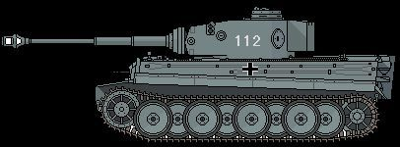
Figure 1Panzer leher
+2
17th SS PG

